Internship Report

Date: 24-12-2025

Contents:

- Analysis of battery temperature variation to the conductive & convective Heat Transfer parameters

- Modelling of R-1234yf Closed-Loop Vapor Compression Refrigeration Cycle in MATLAB/Simulink

Submitted for:
NoonRay Energy Pvt. Ltd
IIT Madras Industrial Park, Chennai

Submitted by:
Nalluru Hemesh,
B. Tech-Mechatronics,
SASTRA University
- Analysis of battery temperature variation to the conductive & convective Heat Transfer parameters

Introduction
Thermal management plays a crucial role in influencing the performance, safety and life span of the battery systems. During operation and charging, batteries generate heat due to internal resistance, electrochemical reactions and inefficiencies. Improper heat removal leads to temperature rise, performance degradation and safety concerns. Understanding the mechanisms of heat transfer and their influence on the temperature variation is very important for effective thermal design.
This work focuses on studying battery temperature behavior influenced by conductive and convective heat transfer parameters.
  - Purpose
The purpose of this study is to analyze the effect of conductive and convective heat transfer on temperature variation of battery system under constant heat generation.
  - Scope
- The battery is modeled as lumped thermal mass.
- Analysis of heat transfer directly to ambient through convection.
- Analysis of heat transfer from battery to cold plate through conduction followed by convection.
- Exploring transient and steady-state temperature responses for different heat transfer parameters.
Detailed fluid flow dynamics and electrochemical battery behavior are not considered.
- System overview
Two separate Simulink models were developed to study the thermal behavior:
A. Convective Heat Transfer Model:
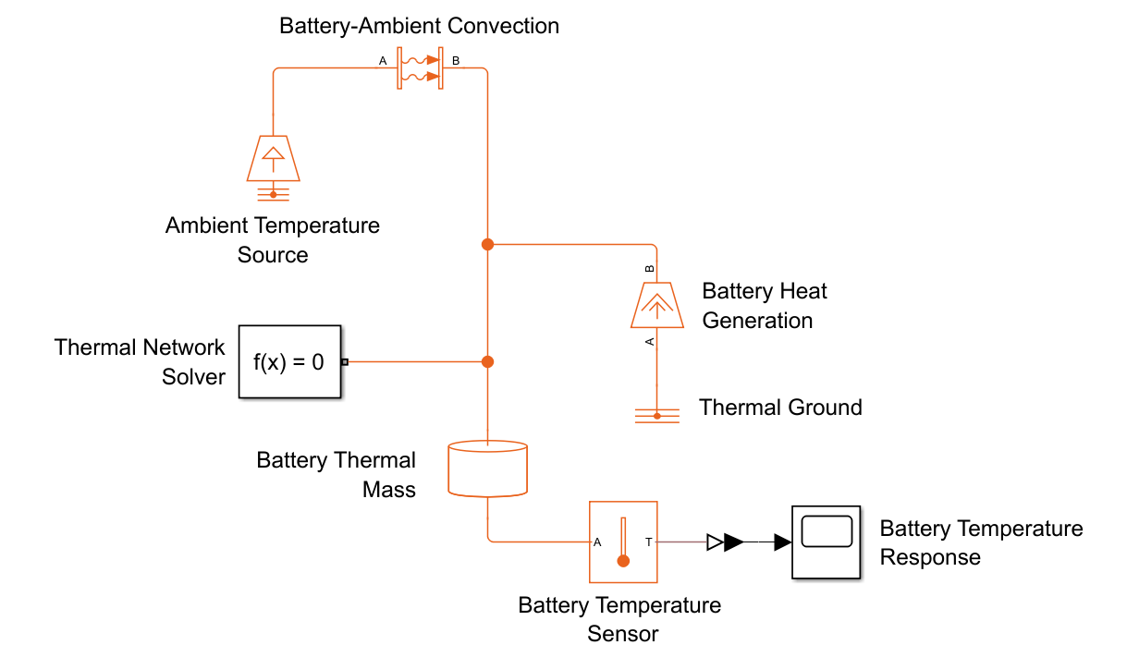

- Conductive Heat Transfer Model with Cold Plate:
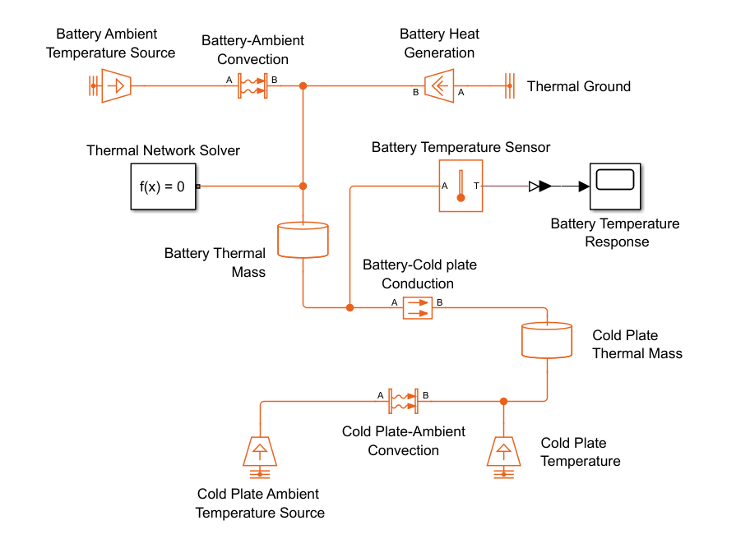
These models represent simplified versions of real battery cooling configurations used for thermal analysis.
  - Blocks & their functions
- Thermal Mass (Battery) : Represents thermal energy storage from battery
- Heat Flow Rate Source : Represents internal heat generation within battery
- Convective Heat Transfer : Models heat loss from solid surface to ambient or coolant
- Conductive Heat Transfer : Models heat transfer between battery and cold plate
- Thermal Mass (Cold Plate) : Represents thermal inertia of cold plate
- Temperature Source : Represents ambient or coolant at constant temperature
- Temperature Sensor : Measures temperature variation with respect to time
- Solver Configuration : Used for solving the physical network

- System Inputs & Outputs

- Convective Heat Transfer Model
Common input parameters are
- Ambient temperature : 313.15 K
- Convection area : 0.94 m²
- Battery mass : 300 kg
- Specific heat capacity : 1000 J/(kg·K)
- Heat flow rate : 1 kW
- Time period : 3600 sec (1 hour)

Case 1: Low convective Heat transfer coefficient = 5 W/m ².K

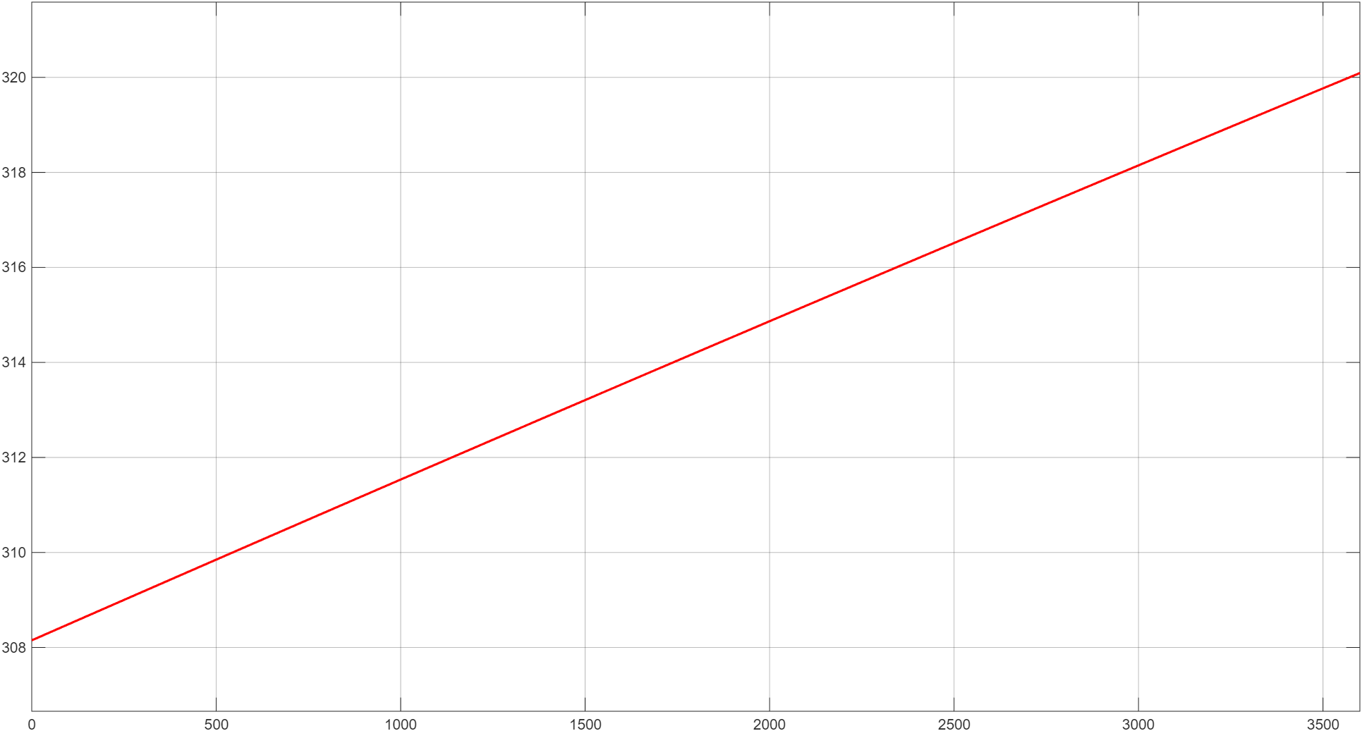

The battery temperature raised from 308 K to 320 K, indicating highest temperature increment among all cases

Case 2: Convective Heat transfer coefficient = 100 W/m ².K
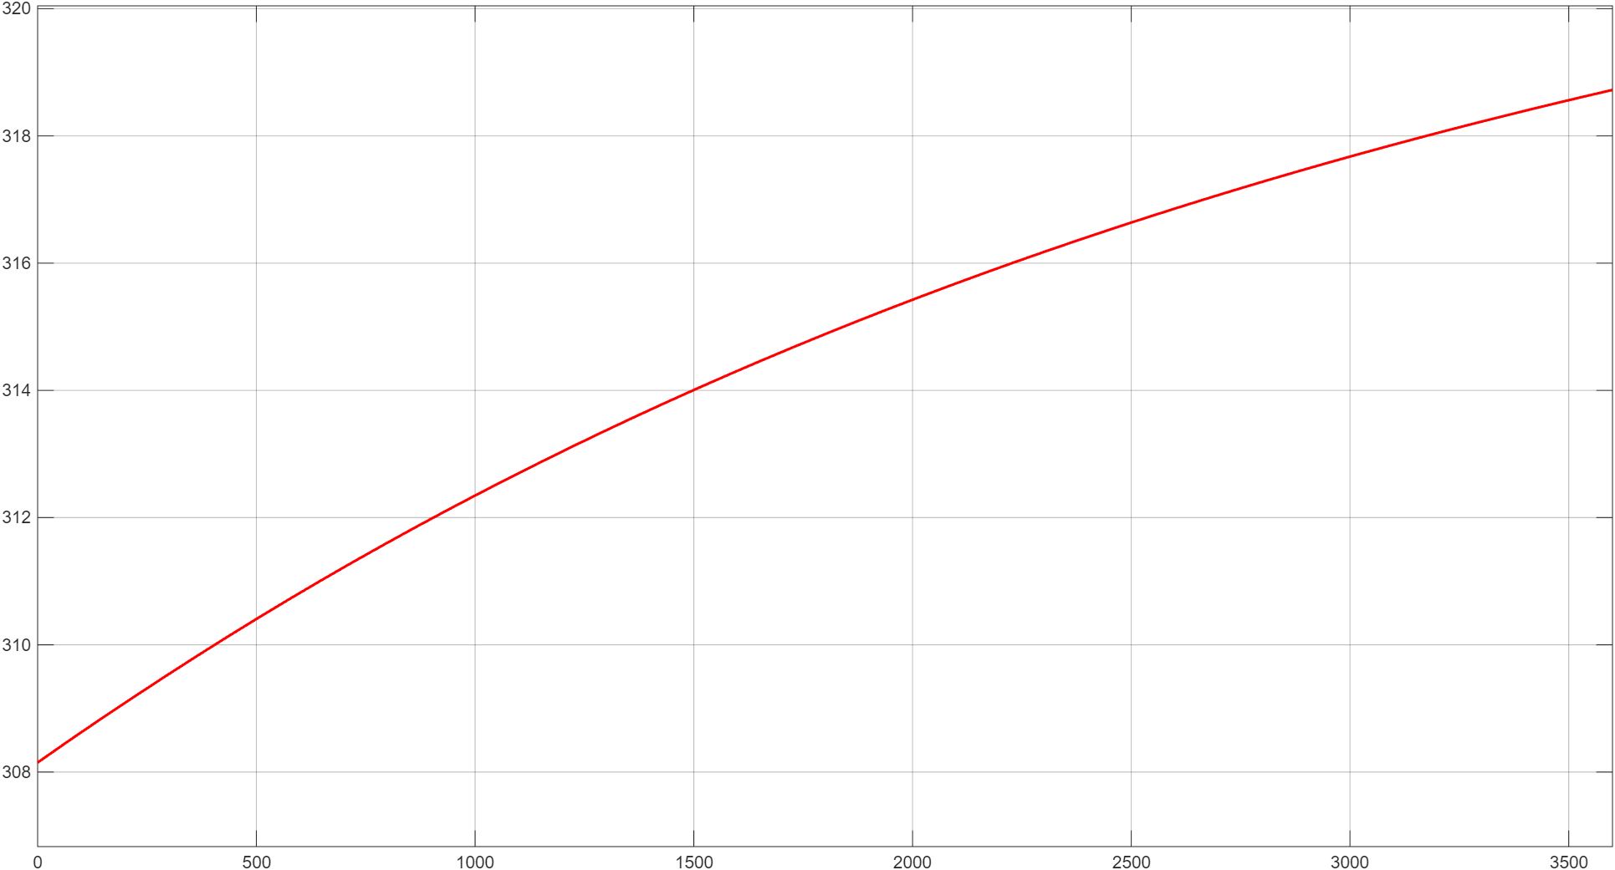
The battery temperature increased from 308 K to 318.7 K, showing a lesser steady-state temperature compared to previous case
Case 3: Convective heat transfer coefficient = 500 W/m ².K

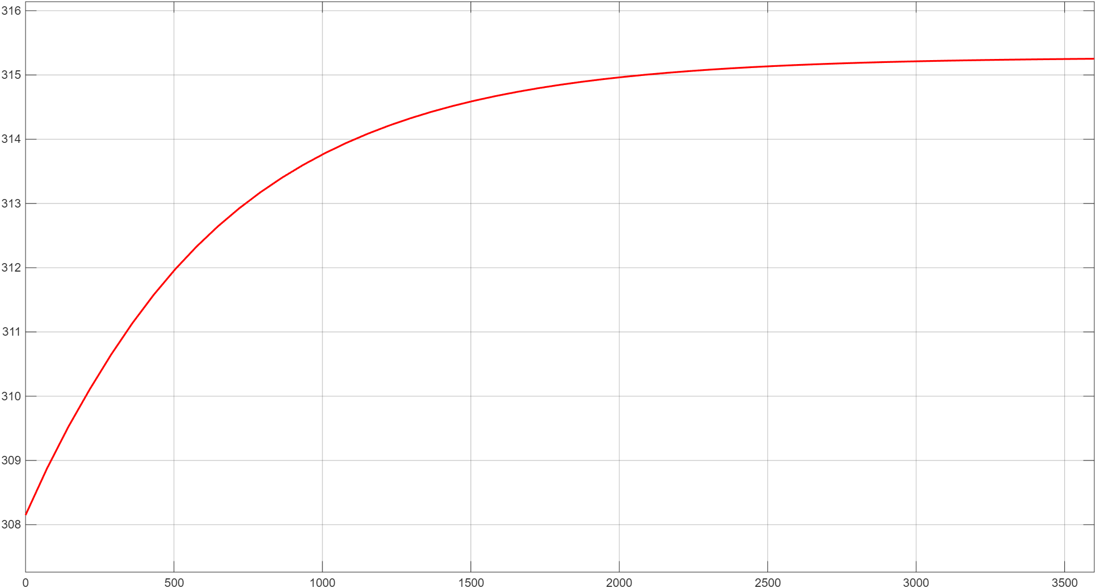

The battery temperature increased from 308 K to 315.2 K indicating lowest temperature rise among all cases

- Conductive Heat Transfer Model
Geometrical details (common for all cases)
- Battery dimensions:
- Length = 500 mm
- Breadth = 400 mm
- Height = 300mm
- Cold plate dimensions:
- Length and breadth same as battery
- Thickness = 5cm
Additional details:
- Ambient temperature = 313.15 K
- Cold plate temperature = 293.15 K
- Battery initial temperature = 308.15 K
- Time period = 3600 sec (1 hour)
- Heat flow rate = 1 kW
- Thermal conductivity = 237 W/m·K

Case 1: Conductive layer thickness = 8mm
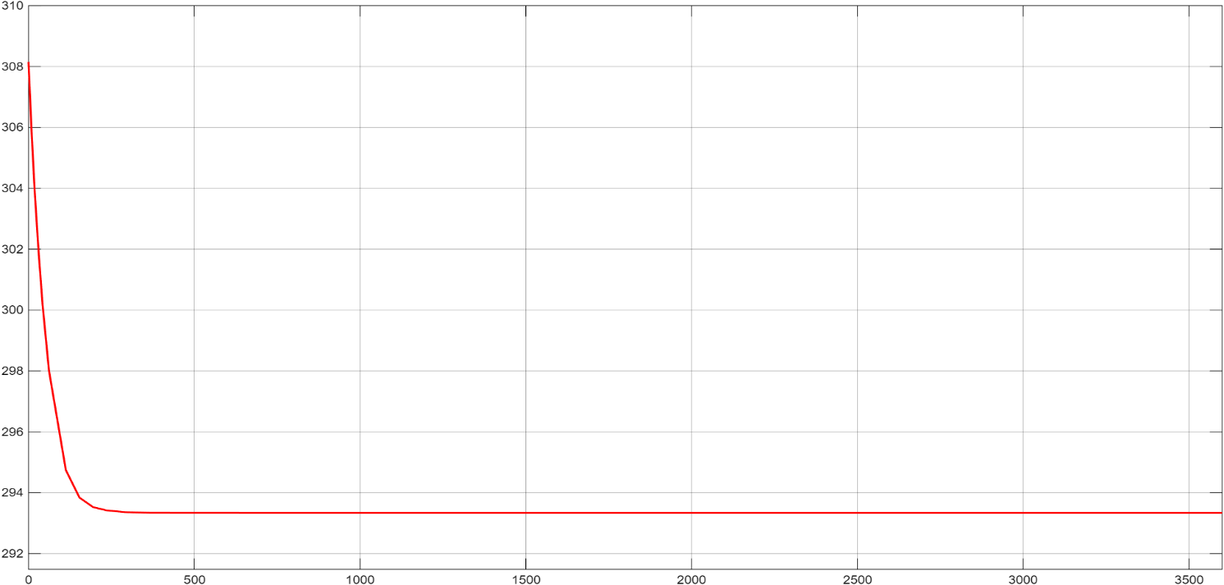
Battery temperature decreased from 308 K to 293.33 K over time and reached a steady state
Case 2: Conductive layer thickness = 5mm
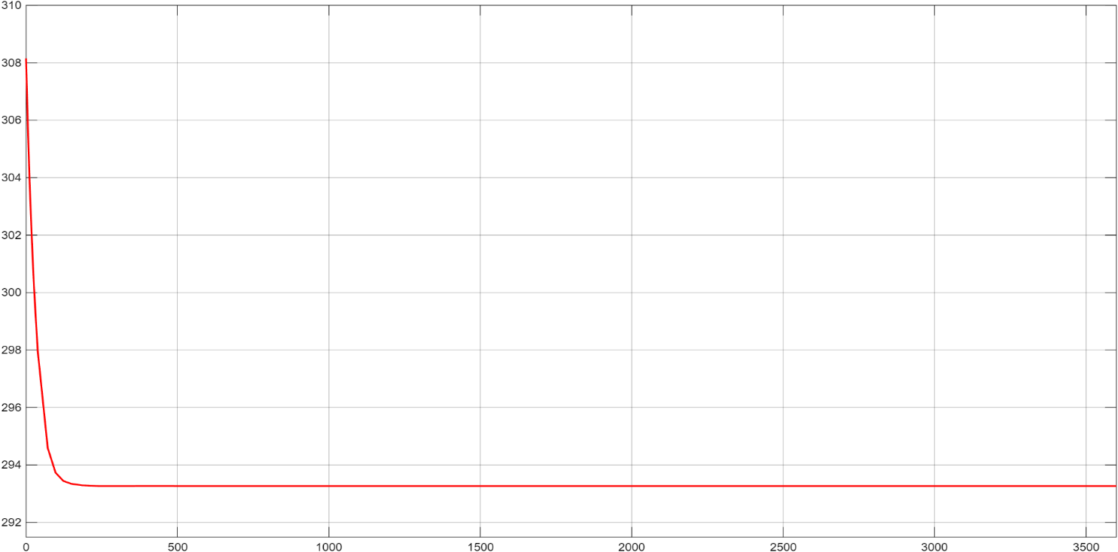
The battery temperature decreased from 308 K to 293.266 K, showing a slightly lower steady-state temperature compared to case 1
Case 3: Conductive layer thickness = 3mm

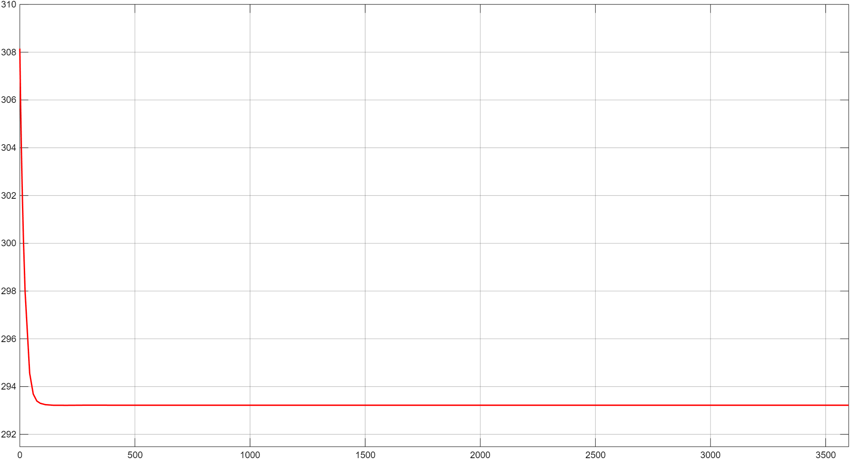
Despite a higher heat generation rate, the battery temperature decreased from 308 K to 293.2196 K and stabilized

- Observations
Convective Heat Transfer:
- In convective heat transfer model, battery temperature rise is inversely proportional to the convective heat transfer coefficient.
- Higher convective heat transfer coefficient resulted in a lower steady-state battery temperature by increasing heat rejection to ambient.
- Lower the convective heat transfer coefficient, higher the temperature rise and steady-state temperature shifted upward.
- The temperature response shows a gradual transient, indicating convection-limited heat removal.
Conductive Heat Transfer:
- In all the cases, battery temperature rapidly decreased from initial value and stabilized close to cold plate temperature.
- Reducing the conductive layer thickness results in faster initial temperature drop due to lower thermal resistance.
- Decrease in the conductive layer thickness resulted a tiny reduction in steady-state battery temperature.

- Conclusion

- Convective cooling effectiveness is primarily governed by the magnitude of convective heat transfer coefficient.
- Conductive cooling effectiveness is dependent on the interfacial thermal resistance between battery and cold plate.
- Cold-plate based conductive cooling provides rapid thermal stabilization compared to direct convection.
- The simulations confirm that conductive cooling is more effective for maintaining lower battery temperatures under steady heat generation.

- Modelling of R-1234yf Closed-Loop Vapor Compression Refrigeration Cycle in MATLAB/Simulink

- Introduction
This report focuses on modelling, simulation and analysis of a closed-loop vapor-compression refrigeration system developed using MATLAB (Simscape). The model consists of an evaporator, compressor and condenser blocks and P-H diagram (2p) block to verify thermodynamic behavior through a Pressure-Enthalpy (P-H) diagram.
The model was created to understand how various thermodynamic parameters influence system performance. Throughout the process, I focused on replicating the actual behavior of refrigeration systems used in thermal management applications.
- System Overview
The developed system represents a closed-loop refrigeration cycle with refrigerant R-1234yf. The model consists of interconnected two-phase fluid components forming a continuous refrigerant flow loop. Major subsystems are:
- Evaporator
- Compressor
- Condenser
The system is modeled to track refrigerant thermodynamic states throughout the cycle, with pressure-enthalpy data used as primary output for cycle validation and performance analysis.
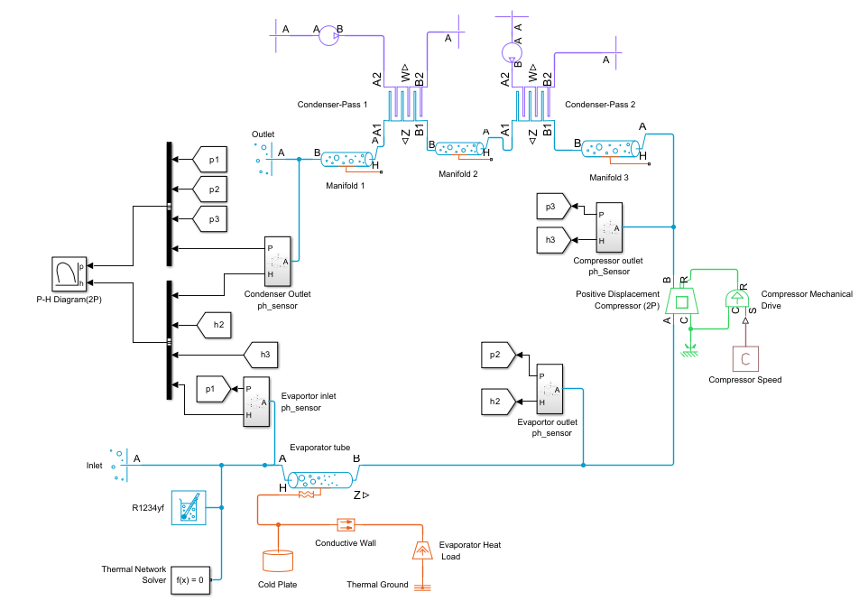
- Blocks and their functions
- Evaporator Tube
Models the heat absorption process where low-pressure refrigerant absorbs thermal energy and undergoes phase change.

- Evaporator Heat Load & Conductive Wall
Represents external thermal input to the evaporator through a conductive path.

- Cold plate
Represents a lumped thermal mass that absorbs applied heat load and transfers it to refrigerant through evaporator via conduction.

- Thermal ground
Defines zero reference temperature node of thermal network, ensuring a stable and well-posed thermal energy balance.
- Positive Displacement Compressor (2-Phase)
Increases the pressure and enthalpy of the refrigerant by converting mechanical work into thermal energy.
- Compressor Mechanical Drive & Speed Input
Supplies controlled mechanical energy to the compressor. This allows evaluation of system response to different compressor speeds and operating conditions.
- Condenser Pass-1 and Pass-2
Models heat rejection from high-pressure refrigerant to the surroundings in multiple stages.
- Inter-Pass Manifolds
Provide flow continuity and thermal capacitance between condenser passes. These blocks help prevent flow instability and flooding during transient conditions.
- Refrigerant Property Definition (R-1234yf)
Defines thermophysical properties of the working fluid. This ensures accurate phase change behaviour and realistic pressure–enthalpy relationships.
- Thermodynamic State Sensors (p–h Sensors)
Measure pressure and enthalpy at key locations in the cycle and also extracts state points for validation using the P–H diagram.
- P–H Diagram Generator
Converts simulation data into a pressure–enthalpy plot. This block validates the correctness of the refrigeration cycle model against thermodynamic theory.
- Thermal Network Solver
Ensures numerical convergence and conservation of energy within the thermal network.

- Output Results (PH Diagram analysis)
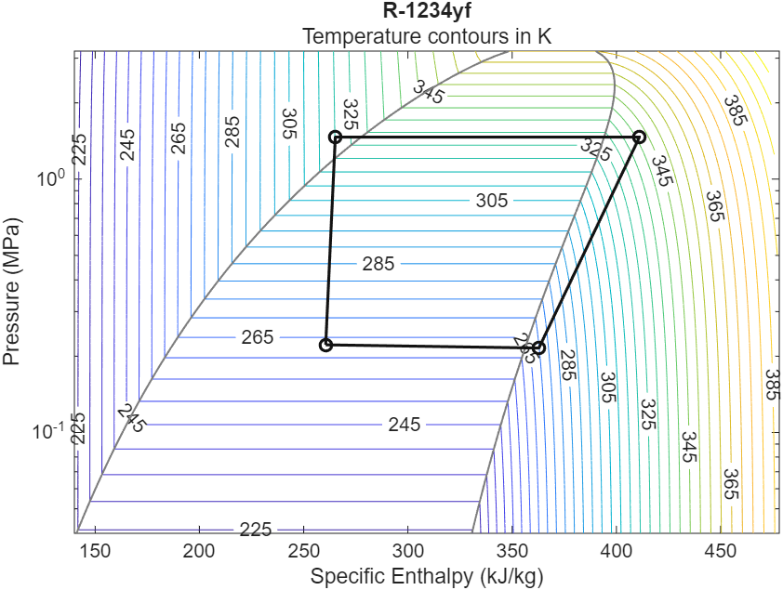
The simulated refrigeration cycle plotted on Pressure-Enthalpy (P-H) diagram for R1234yf clearly demonstrates all four thermodynamic processes.

- Evaporation:

• Horizontal movement toward higher enthalpy.
• Confirms effective heat absorption in the evaporator.

- Compression:
• Refrigerant’s pressure and enthalpy rise sharply at compressor outlet.
• Indicates mechanical energy conversion into refrigerant internal energy.

- Condensation (Heat Rejection):
• Enthalpy reduction at nearly constant pressure.
• Confirms effective heat rejection and phase change.

- Pressure reduction across flow restrictions:
• Pressure drop occurs between condenser outlet and evaporator inlet due to flow resistances.
• This pressure reduction provides throttling required for completing the refrigeration cycle.
- Observations:
- The simulated P-H loop for R-1234yf clearly exhibits all four thermodynamic processes-evaporation, compression, condensation and throttling.
- The refrigerant reaches a superheated state at the evaporator outlet, confirming full heat absorption from the load.
- Distinct enthalpy rise across compressor is observed at elevated pressure levels, validating proper conversion of mechanical work into refrigerant internal energy.
- Enthalpy gradually reduces across the condenser with state moving from superheated vapor to sub-cooled liquid, confirming adequate heat rejection capability.
- Although no expansion valve is modelled, pressure drop across manifolds and interconnecting flow elements produces implicit throttling effect.
- The cycle geometry on the P-H diagram remains stable without divergence indicating appropriate initial conditions.
6. Conclusion:
- The simulated results align well with refrigeration theory, as verified through pressure-enthalpy analysis, demonstrating correct phase transitions and energy balance across all components.
- The model architecture based on modular evaporator, compressor and condenser subsystems provides scalable framework for future enhancements such as expansion valve control.
- Overall, this work establishes a strong foundation for advanced thermal management studies, including EV battery cooling and controlled refrigeration system design, using physics-based simulation techniques.

